1.
A Project Report On

Movie Search using API

Submitted in partial fulfillment of the requirement for the BCA Semester-4 Python Programming Subject Final Examination.
BACHELOR OF COMPUTER APPLICATIONS
(B.C.A.)

Academic Year 2025 – 26

Ziyan Panjwani- (92400527229)

Internal Guide
Kishita Doshi



Rajkot-Morbi Road, At & PO : Gauridad, Rajkot 360 003. Gujarat. India.

CONTENTS

Chapters | Particulars | Page No.
1 | SYNOPSIS | 4
2  2.1  2.2  2.3  2.4 | PREAMBLE  General Introduction Statement of Problem  Objective and Scope of the Study Module Description with functionality | 5
3  3.1  3.2  3.3  3.4 | SYSTEM DESIGN AND DEVELOPMENT  Data Flow Diagram (DFD) Table Structure  Menu Design  Screen Design (Screen shots with short description) | 7
4 | CONCLUSION | 15
5 | LEARNING DURING PROJECT WORK | 15
6  6.1  6.2 | BIBLIOGRAPHY  Online References Offline References | 16

Figure Index

Sr.No. | Figure No. | Particulars | Page No.
1 | Fig 3.1 | Level 0 DFD — Data flow within system | 7
2 | Fig 3.2 | Table Structure (Users File – users.txt) | 8
3 | Fig 3.3 | Menu design - Info about menu | 9
4 | Fig 3.4 | Screen Design - screenshots of application | 10
5 | Fig 3.4.1 | Screenshot of Login screen | 11
6 | Fig 3.4.2 | Screenshot of Main Screen | 11
7 | Fig 3.4.3 | Screenshot of Movie Search screen | 12
8 | Fig 3.4.4 | Screenshot of Trending Movies screen | 13

TABLE INDEX

Sr.N  o. | Table No. | Particulars | Page No.
1 | Table 3.2.1 | User table | 8

CHAPTER 1 SYNOPSIS

The Movie Search Application is a Python-based desktop application that helps users to search for movies and view their details easily. The system is developed using Python programming language and uses the TMDB (The Movie Database) API to fetch real-time movie information such as title, release year, rating, and overview.
The application provides a simple and user-friendly graphical user interface (GUI) using Tkinter. Users can register and log in to the system. After logging in, they can search for movies and also view trending movies.
The system uses file handling to store user data such as username and password in a file named users.txt. It also includes basic error handling to manage issues like invalid input or no internet connection.
This project demonstrates the practical implementation of important Python concepts such as API integration, GUI development, file handling, and user interaction. It is a simple and useful application that can be further improved by adding more features like favorites, database integration, and better user interface

CHAPTER 2 PREAMBLE

General Introduction:
Movies are one of the most popular sources of entertainment. Before watching a movie, users often search for information such as rating, release year, and story. However, searching on multiple websites can be time-consuming.
The Movie Search Application provides a simple solution to this problem. It allows users to search for movie details in one place. The application uses the TMDB API to fetch real-time data and displays it through a user-friendly interface built using Tkinter. The system is designed to be simple, fast, and easy to use for all users.

Statement of Problem:

Users face the following problems while searching for movie information:
- It takes time to visit multiple websites
- No single platform provides complete information
- Difficult to get fast and accurate results

The system aims to solve these problems by:
• Providing quick movie search results
• Displaying all details in one place
• Offering an easy-to-use interface

Objective and Scope of the Study:

Objectives:
- To develop a movie search application using Python
- To integrate TMDB API for real-time movie data
- To design a graphical user interface using Tkinter
- To implement login and registration system
- To display trending movies

Scope
- The application can be used by anyone to search movie details
- It can be enhanced with features like favorites and recommendations
- It can be converted into a web or mobile application
- Database integration can be added in future

Module Description with Functionality:

1. Login Module
This module allows users to register and log in. User data is stored using file handling.

2. Search Module
This module allows users to enter a movie name. The system sends a request to the TMDB API and retrieves movie data.

3. Display Module
This module shows movie details such as title, release year, rating, and overview.

4. Trending Module
This module displays trending movies fetched from the API.

5. GUI Module
This module handles the user interface using Tkinter. It includes input fields, buttons, and display area.

CHAPTER 3
SYSTEM DESIGN AND DEVELOPMENT

Data Flow Diagram (DFD)

The Data Flow Diagram represents how data flows within the system.
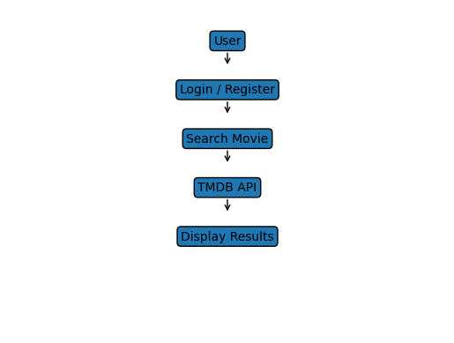

Process Flow:
The process flow of the system describes how the application works step by step:
- The user opens the application.
- The user registers or logs in using username and password.
- After successful login, the user enters a movie name in the search box.
- The application sends a request to the TMDB API.
- The TMDB API returns movie data to the application.
- The application processes the data.
- The movie details are displayed to the user.
- The user can also view trending movies.
- The user can close the application after use.

Table Structure

    - Users table:

Field Name | Data type | Description
username | TEXT | Stores username
password | TEXT | Stores password

Menu Design

Main Menu:
  - Trending Movies
  - Top Rated Movies
  - Popular Movies
  - Search Movie
  - View Favourites
  - Feedback Form

Screen Design

: Login Screen: 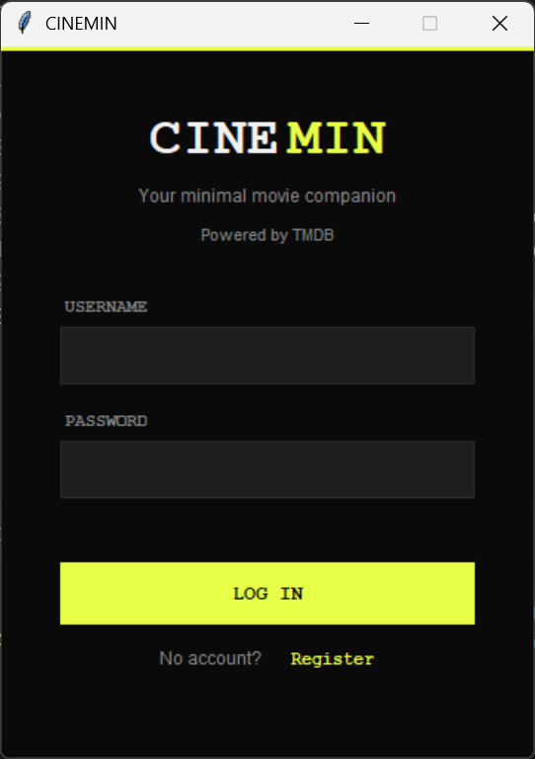

User and Admin enters username and password to login or register.

: Main Dashboard

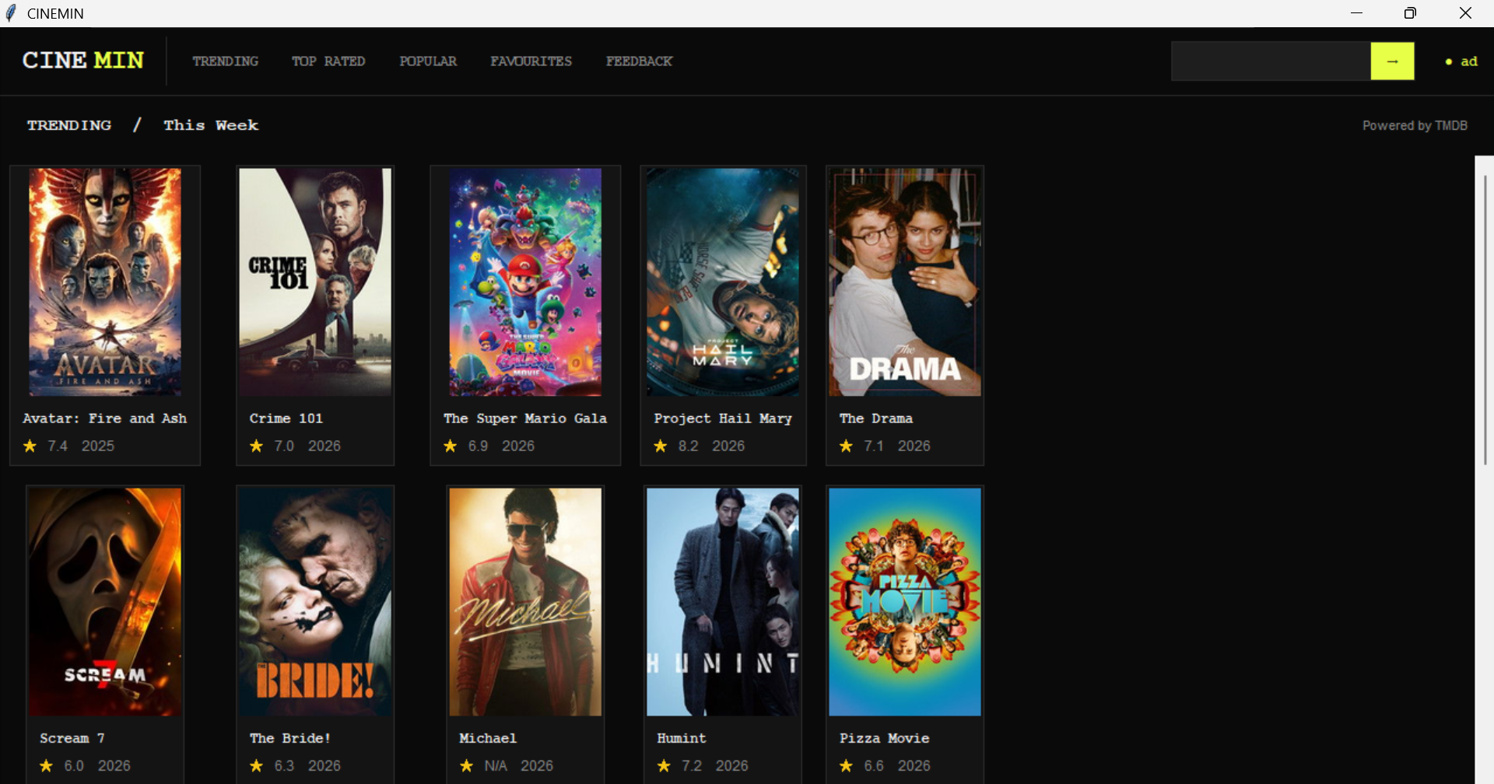

Displays movie categories and search bar.

: Movie Detail Screen

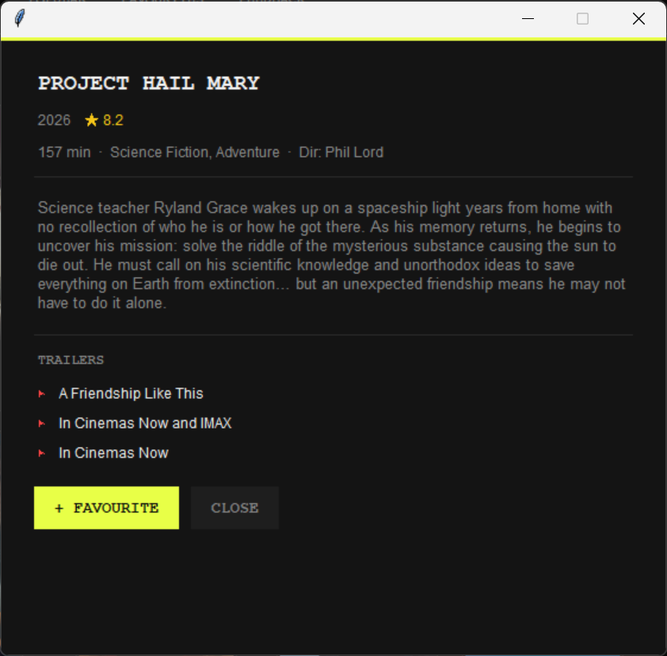

Displays complete movie details with director, poster,description,plot,favourite button and imdb ratings,trailers link.

: Favourites Screen

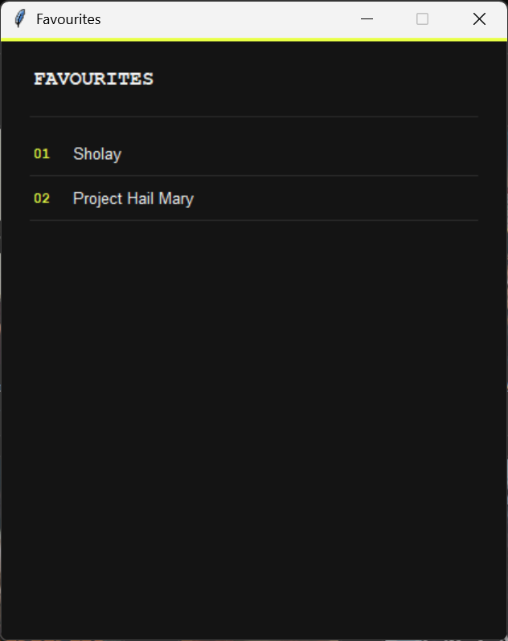

Shows saved favourite movies names.

: Feedback Form

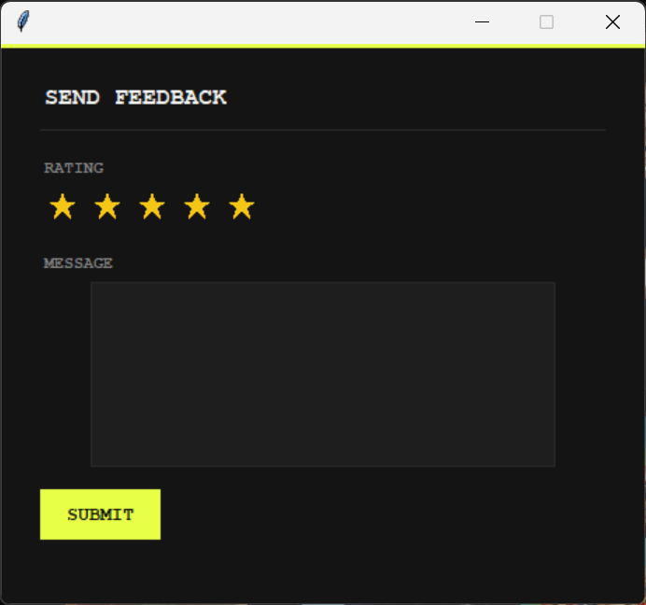

Displays Feedback form including ratings

CHAPTER 4 CONCLUSION

The Movie Search Application is a comprehensive Python-based system that integrates a graphical user interface (GUI), API functionality, and user management features. It provides users with a seamless experience to search, browse, and explore movies efficiently, while also offering administrative controls and analytical insights. This project emphasizes practical application development using Python and demonstrates strong capabilities in GUI design, API integration, and overall system architecture.

CHAPTER 5

LEARNING DURING PROJECT WORK

Gained practical knowledge during the project development process.
Developed a user-friendly GUI using Tkinter.
Integrated APIs using request-based methods.
Implemented image processing using PIL.
Improved performance through multi-threading techniques.
Managed data storage using file handling methods.
Designed and implemented a user authentication system.

CHAPTER 6 BIBLIOGRAPHY

Online References
    - https://www.themoviedb.org/
    - https://docs.python.org/
    - https://pillow.readthedocs.io/

Offline References
    - Programming Python – Mark Lutz (O'Reilly) – for tkinter

